

TUDU Crew
Strategy & Direction Document

1. Overview
TUDU Crew is a team of outgoing brand ambassadors, paid to travel to events and experiences, filming and creating content that brings the TUDU brand to life. Crew members are the face of TUDU out in the world — attending events, interviewing people, checking bucket-list items off, and documenting it all for TUDU's audience.
The Crew also works alongside the TUDU Foundation, helping film and produce content from Foundation tour stops, tying the two initiatives together under one consistent on-camera team.

2. Role & Responsibilities
- Travel to different events and experiences, filming and creating content along the way.
- Interview attendees, hosts, and organizers on location.
- Work through bucket-list-style challenges and experiences (tying into TUDU's Bucket List Mode).
- Collaborate with the TUDU Foundation to film and produce tour content.
- Travel between locations using a dedicated TUDU motorhome.

3. Content Strategy
Crew members are expected to produce and post content on a regular cadence, keeping TUDU's channels active between larger releases.
- Short-form clips posted multiple times per week.
- Footage combined with TUDU Foundation content to produce longer-form YouTube videos.
- A consistent posting rhythm to build and retain an audience across platforms.
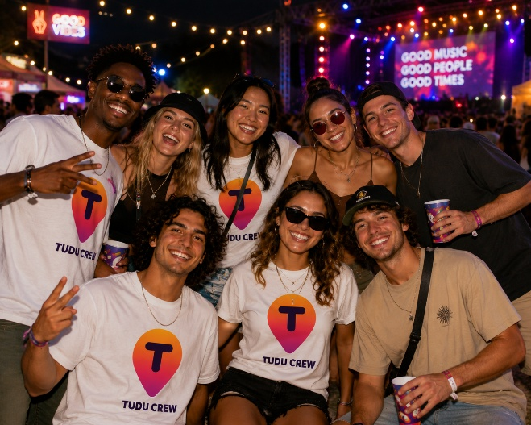
Concept: on-the-road content creation

4. Platforms & Channels
TUDU Crew will need its own dedicated presence, separate from (but linked to) the main TUDU brand accounts:
- A TUDU Crew Instagram page for short-form updates, behind-the-scenes content, and event highlights.
- A TUDU YouTube channel for longer-form videos, event recaps, interviews, and Foundation collaborations.

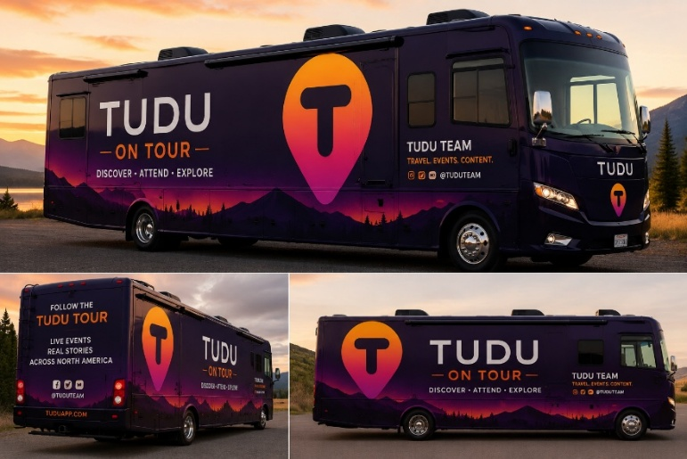
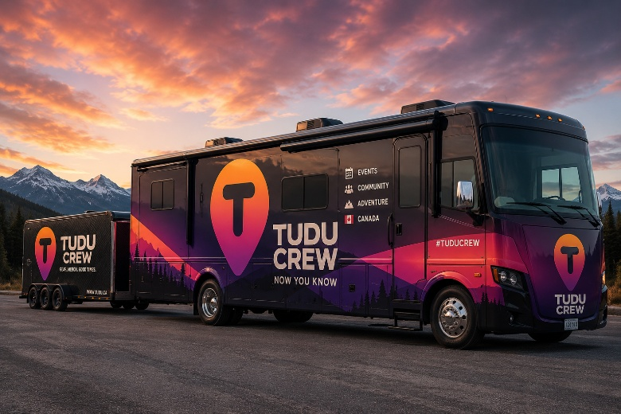

Concept: TUDU Crew Motorhome Concepts

5. The TUDU Motorhome
TUDU Crew will travel using a dedicated TUDU-branded motorhome, giving the team mobility between events while reinforcing the same on-the-road, adventure-driven brand identity used across TUDU and the TUDU Foundation.
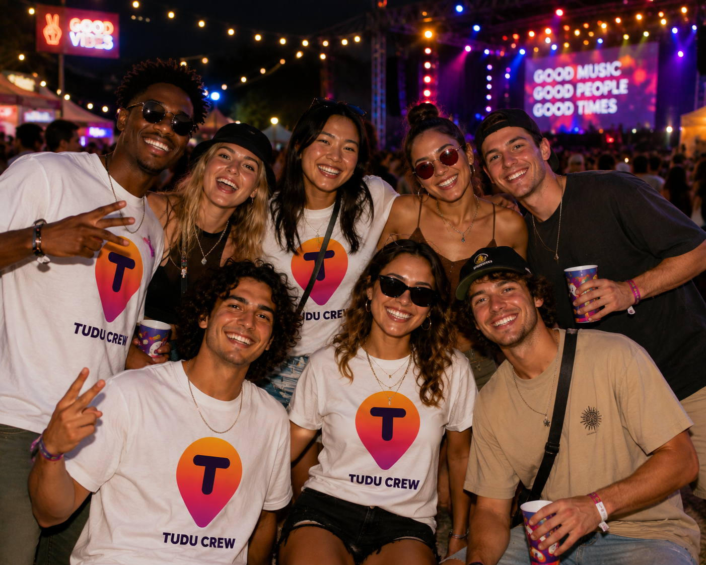
Concept: the TUDU Crew social and video content

6. Relationship to TUDU Foundation
TUDU Crew and the TUDU Foundation are designed to operate side by side: the Foundation provides the mission-driven story (kids, adventures, impact), while the Crew provides the on-camera talent and content production to tell that story — alongside their own independent event coverage and bucket-list content.

7. Open Considerations
Direction note: Define hiring criteria and selection process for Crew members — on-camera comfort, travel availability, content creation skill, and alignment with TUDU's brand tone should all factor in.
Direction note: Confirm content ownership and usage rights — Crew members should have clear agreements around who owns footage they create and how TUDU can reuse it.
Direction note: Decide on a content approval workflow so posts stay on-brand without slowing down the 'multiple times a week' posting cadence.
Direction note: Determine posting/travel schedule structure — is this a full-time role, seasonal, or event-based/contract work?
Direction note: Clarify how TUDU Crew content and TUDU Foundation content will be visually distinguished (or intentionally blended) across shared channels.
Direction note: If Crew members will appear alongside children during Foundation tour stops, the same background-check and media-release requirements noted in the Foundation document should apply here as well.

